**Pooja Bahuguna**

**4085**

**1.Create a directory "exercise" inside your home directory and create nested(dir1/dir2/dir3) directory structure inside "excerise" with single command.**

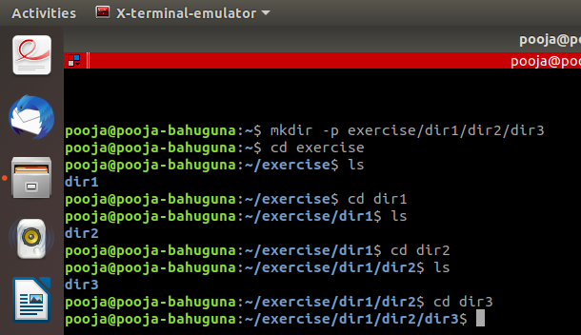

**2.Create two empty files inside dir2 directory: emptyFile1,emptyFile2 in single command and Remove the dir2 directory.**

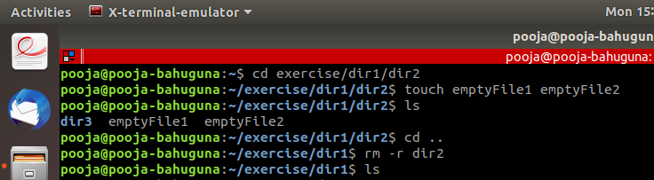

**3.Create one file file.txt containing text "hello world" and save it.**

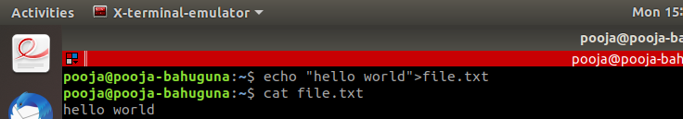

**4..Find a "passwd" file using find command inside /etc. copy this files as passwd_copy and then rename this file as passwd_backup.**

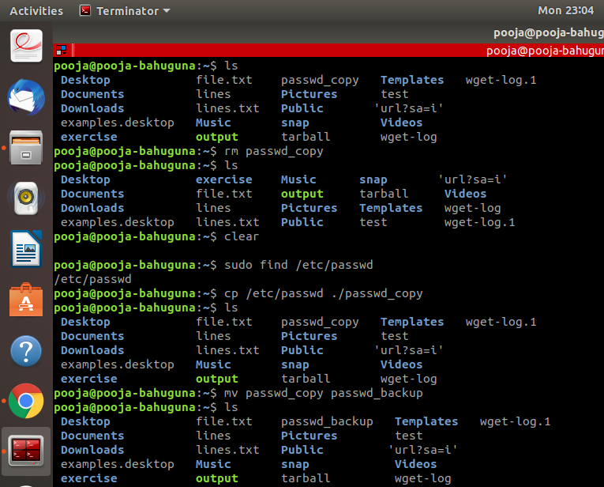

**5.Try reading passwd_backup file in multiple tools: less,more,cat,strings etc and find the difference in their usage.**

**Less**

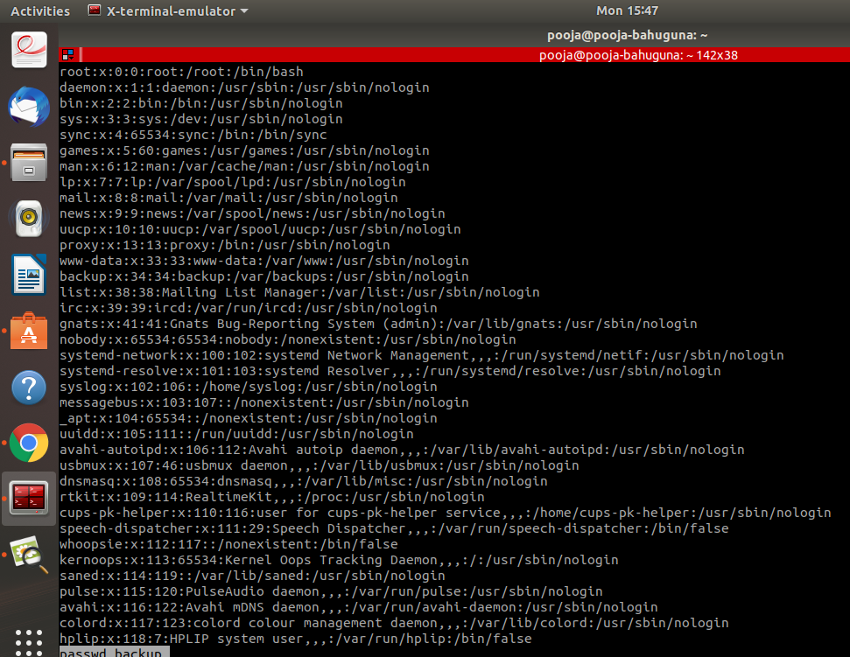

**More**

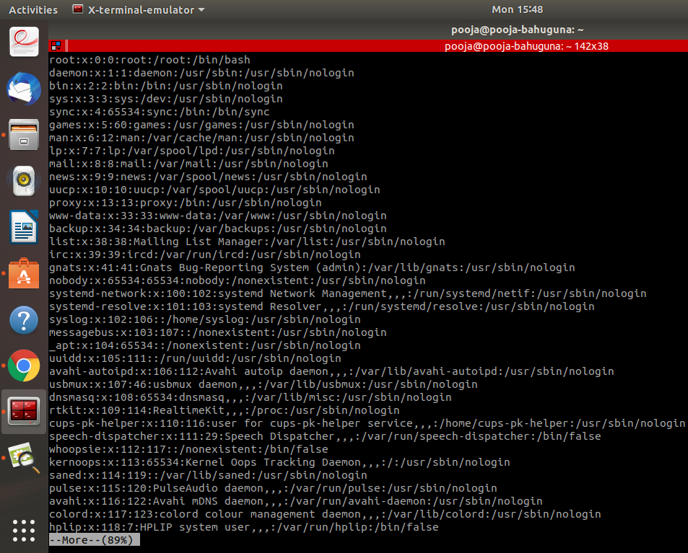

**Cat**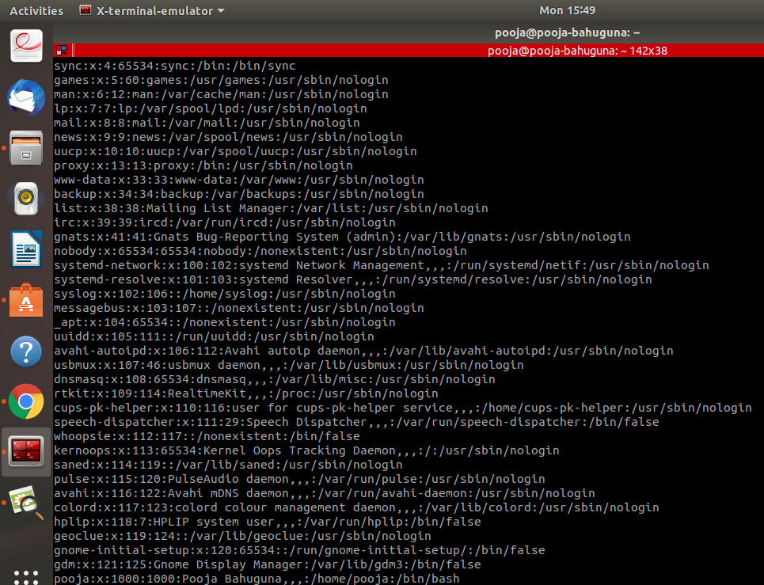

**Strings**

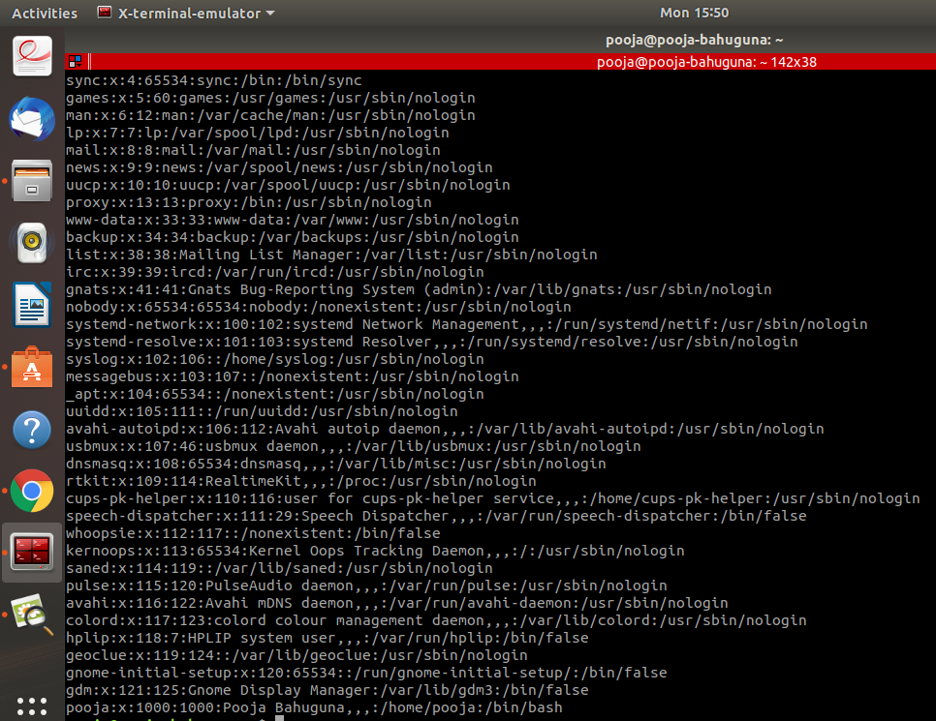

**6.Find out the number of lines in password_backup containing "/bin/false".**



**7.Redirect the output of the above commands into file "output".**

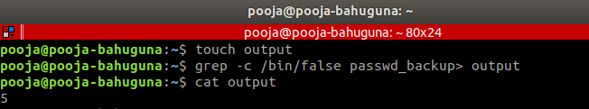

**8.Create a "test" user , create its password and find out its uid and gid.**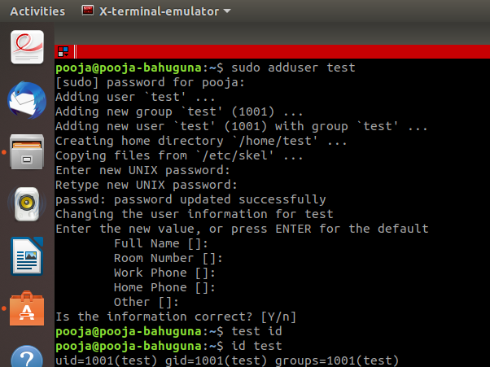

**9.Login as test user and edit the “output” file created above. Since the permission won't allow you to save the changes.**

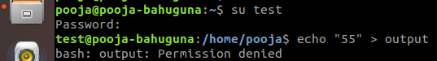

**10. Configure such that test user can edit it.**

**a. Add group owner of the "output" file as the secondary group of testuser and check/change the "output" file permission if it is editable by group. Once done revert the changes.**

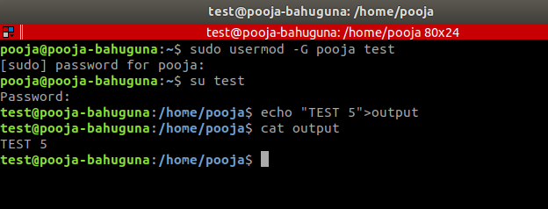

**b. Make the file editable to the world so that test user can access it. Revert the changes after verification**

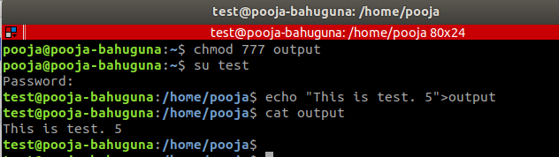

**c. Change the ownership to edit the file.**

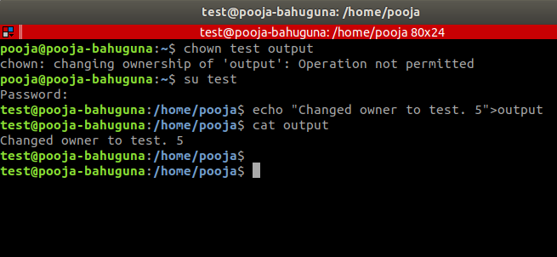

**Try all the options and recommend the best of them.**

**The best option is a.**

**11.Create alias with your name so that it creates a file as "/tmp/aliastesting".**

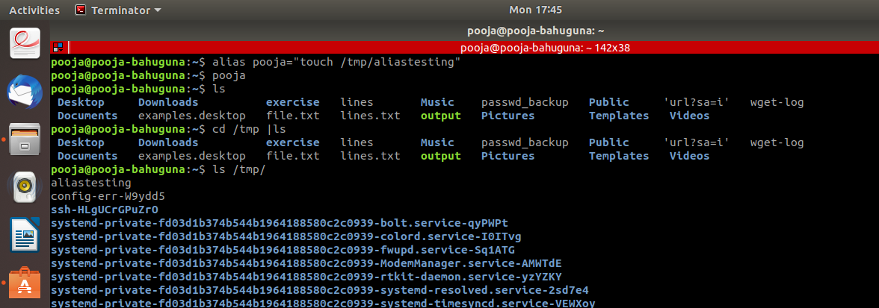

**12. Edit ~/.bashrc file such that when you change to "test" user it should clear the screen and print "Welcome".**

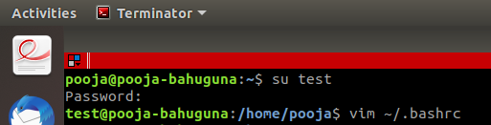

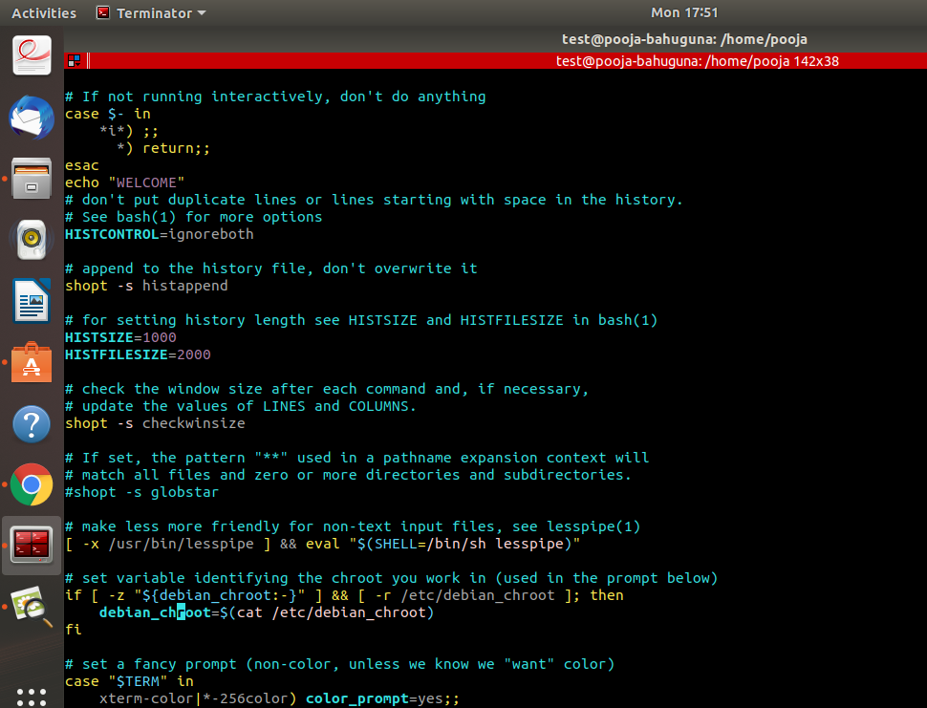

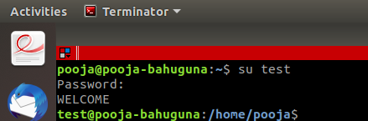

**13.Install zip package.**

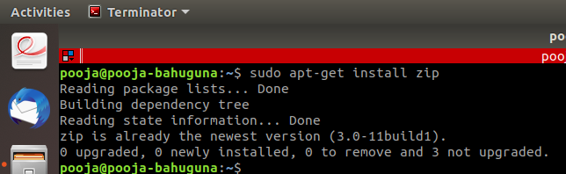

**14.Compress "output" and "password_backup" files into a tar ball. List the files present inside the tar created.**

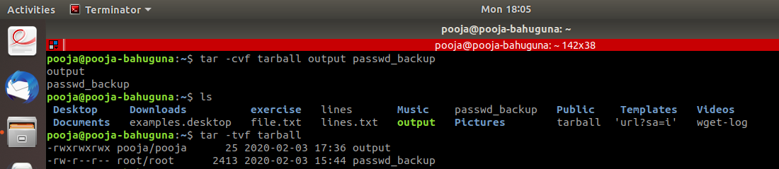

**15. scp this file to test user**

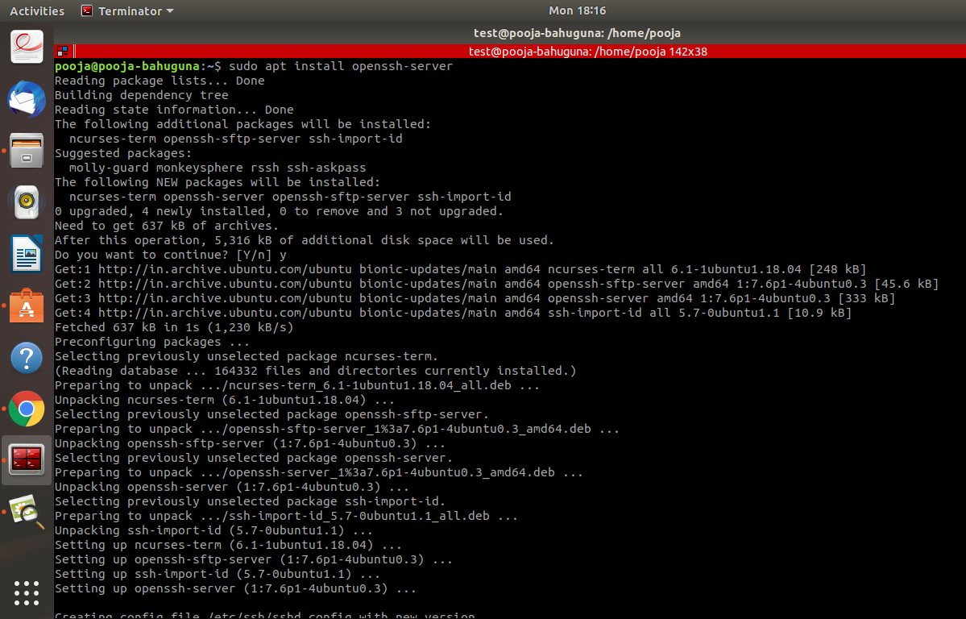

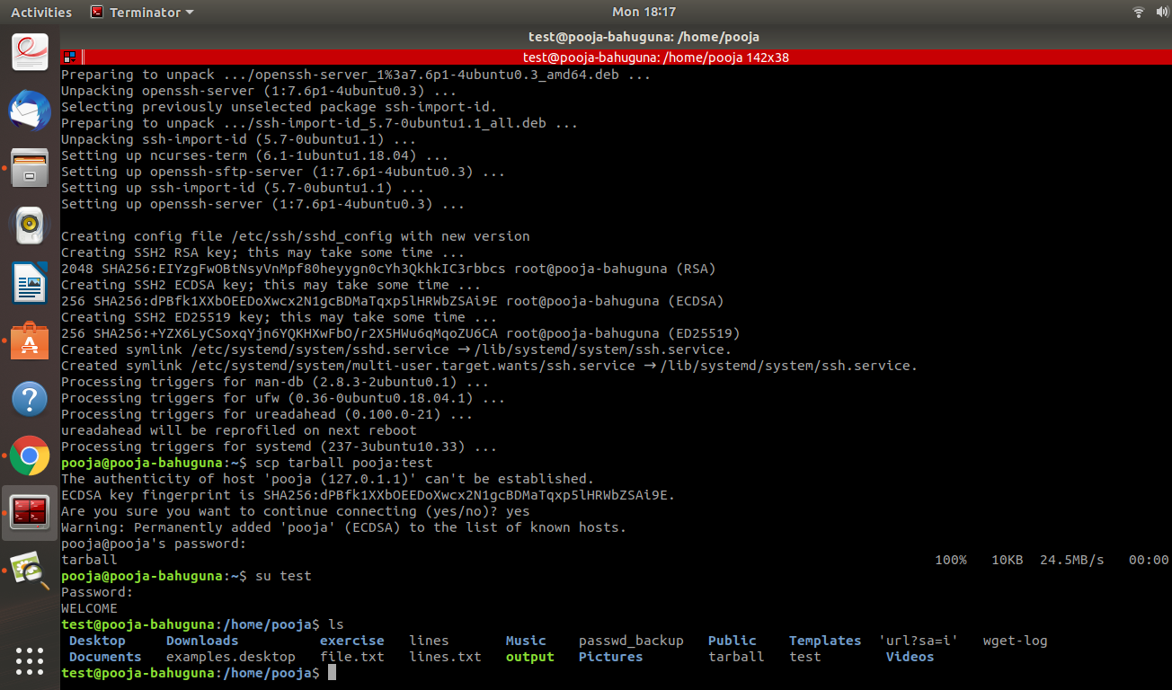

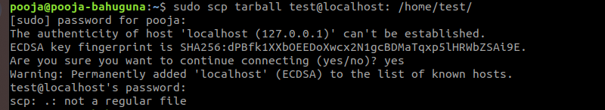

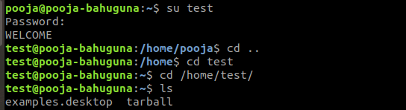

**16. Unzip this tar bar by logging into the remote server.**

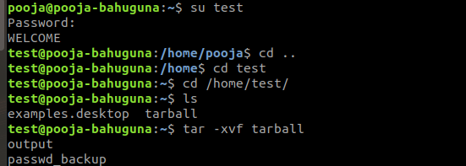

**17. Download any image from web and move to desktop**

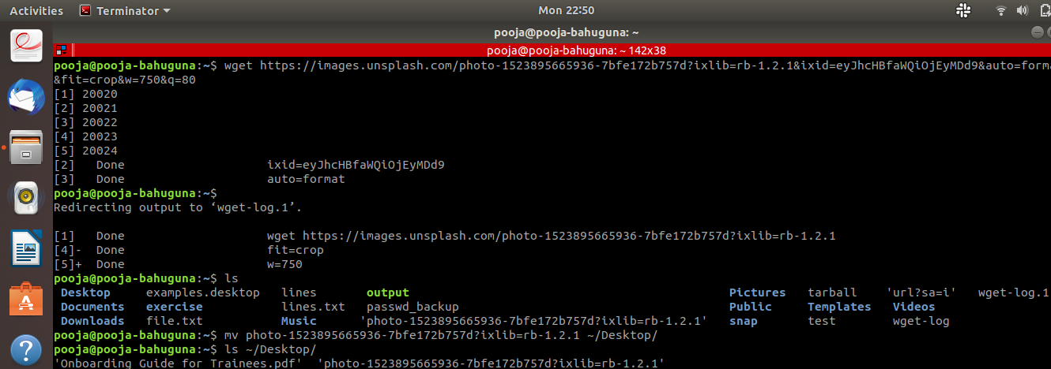

**18. How to get help of commands usages.**

1. **--help**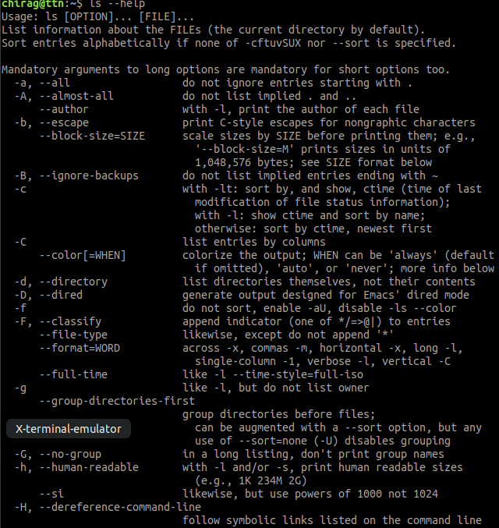
2. **man**

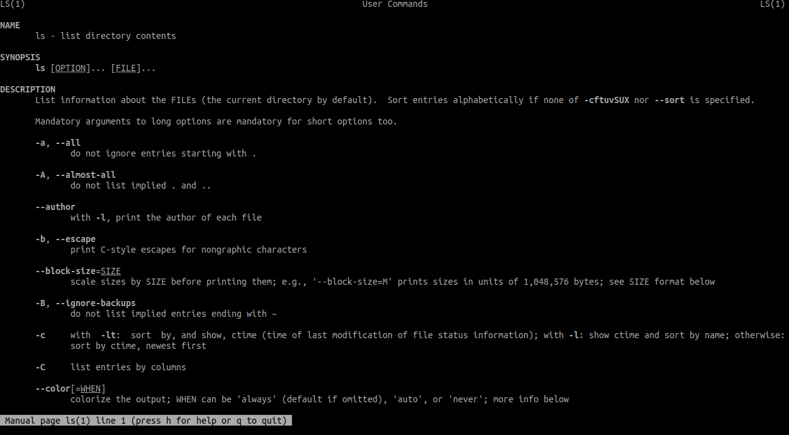

1. **info**

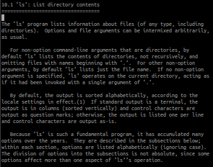

**19. Create a symlink of /etc/services into /tmp/ports-info.**

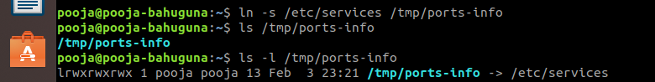

**20. You are appointed as a Software/DevOps Engineer in ABC media services. On your first day you need to troubleshoot a problem. There is a command “xyz” somewhere installed in that linux system. But as a new joinee you do not have any idea about where is that Installed. How can you check that?**

